Sub-Tasks

Viewing only open sub-tasks
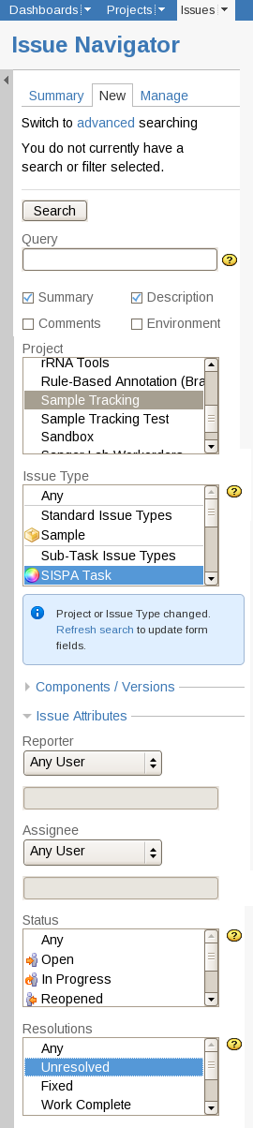  Illustration 1: Issue Navigator - selecting all active Sub-tasks | Select the 'Issue Type's to include all of the sub-task types. Click the first sub-task type in the list and then while holding the shift-key click on the last in the list to select the whole range.  To hide the sub-tasks that have been completed make sure that the 'Resolutions:' field, in the 'Issue Attributes' section, is set to 'Unresolved'.  In this instance 'Unresolved' is the JIRA term meaning all issues that have not completed, not the Sample Tracking term meaning samples that are not going to receive further processing.

Sub-task Actions Available from the Parent Sample's Page
Near to the bottom of the Issue View page is a block of sub-Tasks (Illustration 2: Issue View – including Sub-Tasks section). Note: This block is only shown once the sample has sub-tasks.
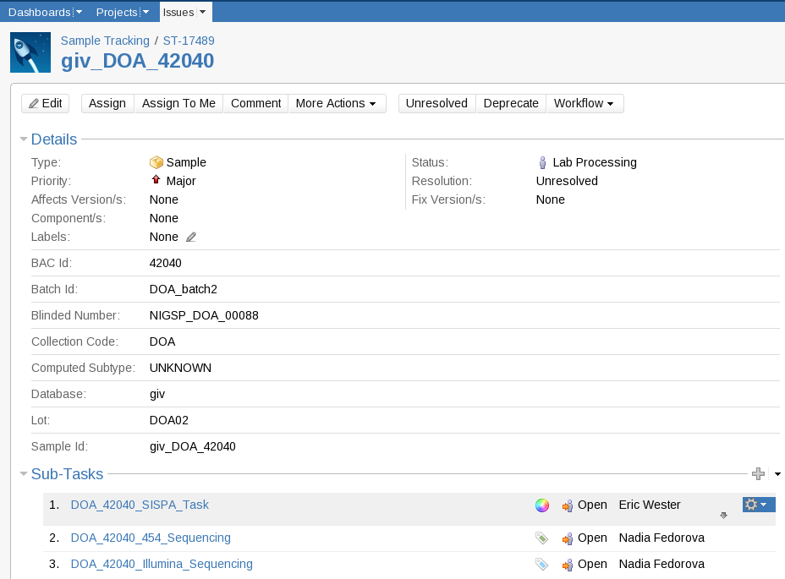
Illustration 2: Issue View – including Sub-Tasks section

Each sub-task is on a separate line. When the cursor is hovering over one of the Sub-tasks a cog shaped icon with an arrow pointing down will appear. Clicking on the icon opens the sub-task's action menu (Illustration 3: Issue View – Sub-Tasks section- Tools drop-down menu).
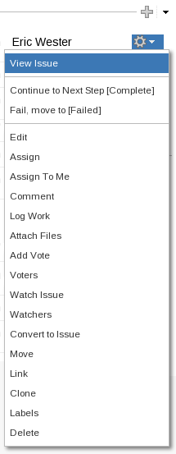
Illustration 3: Issue View – Sub-Tasks section- Tools drop-down menu
The menu is divided into three sections.
- The first links to the Issue View page for the sub-task.
- The second section contains the 'transitions' available for the sub-task. In the example above; clicking 'Continue to Next Step [Complete]' will transition the task the Complete step in the workflow; without having to change to the sub-task's Issue View page.
- The third, and largest, section contains the actions that can be carried out on the sub-task.

